MODULE-3 ASSIGNMENT
- Canvas Screenshot:
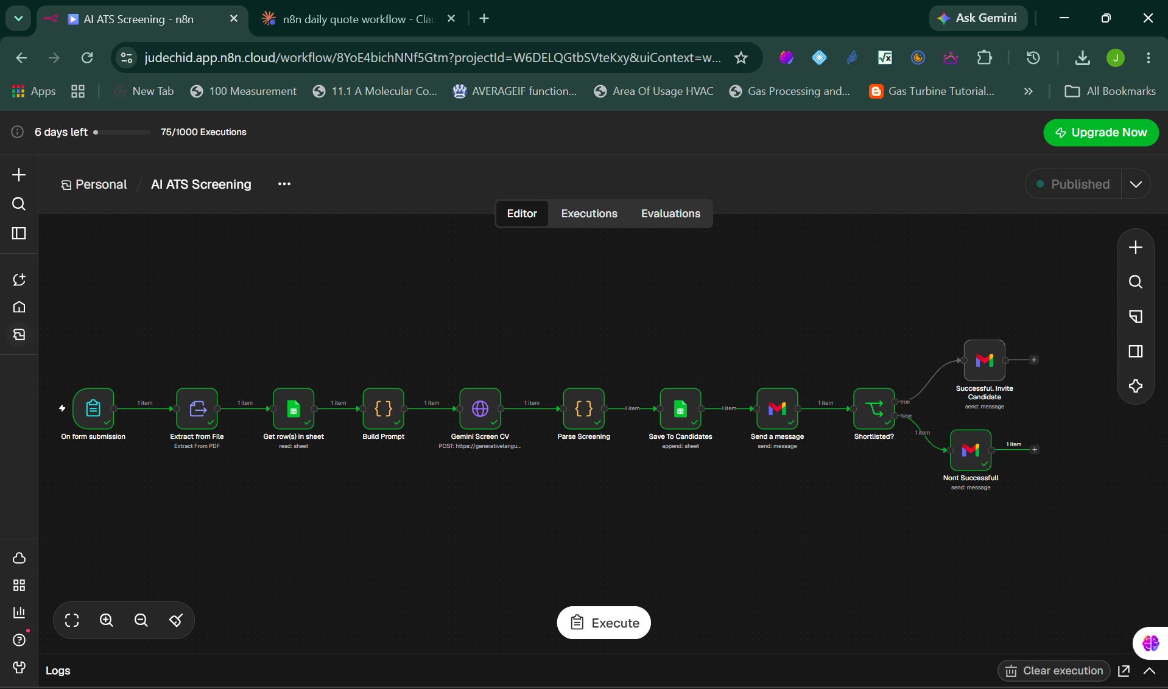
- JSON File:
https://drive.google.com/file/d/1iOAmAwoBSGG7tCA6w9K6qgl5aHFvq_an/view?usp=sharing
- ATS Screening Google Sheets
https://docs.google.com/spreadsheets/d/18odYNTbPZChICihJc4U9VWNEneogptLz3HL2_6w2IRc/edit?usp=sharing
- CVs

- https://drive.google.com/file/d/1OwXfJoPjgi9wypMsTH8ORgl3yN5KhX8j/view?usp=sharing
- https://drive.google.com/file/d/1lCm_0R_o7L4GOI__a6KjIpVhRdLfkuHS/view?usp=sharing

